Executive Summary – FNP Sales Analysis Dashboard

Objective
The primary goal of this dashboard is to analyze and visualize sales performance across various dimensions such as occasions, product categories, customer spending, order trends, and delivery timelines. It provides actionable insights to help the management of Ferns N Petals (FNP) understand revenue drivers, top-performing cities and products, and customer purchase behavior.
Process Followed
1. Data Cleaning in Excel (using Power Query)
- Imported raw sales data into Excel.
- Used Power Query to:
  - Remove duplicates and irrelevant columns.
  - Standardize date, time, and currency formats.
  - Handle missing or inconsistent values.
  - Create calculated columns (e.g., delivery duration).
2. Creating Pivot Tables and Pivot Charts
- Built pivot tables to summarize:
  - Orders and revenue by occasion, category, city, and product.
  - Average spending and delivery times.
  - Monthly and hourly sales trends.
- Used pivot charts to visualize:
  - Sales peaks, top categories, and city-wise performance.
3. Building the Dashboard in Power BI
- Imported the cleaned and summarized data into Power BI.
- Created interactive visuals:
  - KPI cards for total orders, revenue, and average spending.
  - Bar/column charts for sales by occasion, category, and city.
  - Line charts for monthly and hourly trends.
  - Maps for geographical insights.
  - Tables for top products.
- Added filters and slicers for dynamic analysis (e.g., by month, city, category).
- Designed the dashboard layout for clarity and actionable insights.

1. Key Performance Indicators (KPIs)
Metric | Value | Insight
Total Orders | 1,000 | Represents the total number of customer transactions recorded.
Total Revenue | ₹ 35,20,984 | Indicates the overall business revenue generated during the analyzed period.
Average Customer Spending | ₹ 3,520.98 | Shows the average revenue contributed by each customer/order.
Average Days Between Order and Delivery | 5.53 Days | Reflects the average delivery turnaround time, useful for logistics performance evaluation.

2. Revenue Analysis

By Occasion
Highest revenues were recorded during Anniversary, Holi, and Raksha Bandhan, reflecting seasonal and emotional purchase patterns. Birthday and Valentine’s Day occasions contributed moderately. Target marketing campaigns during these top-performing festivals can increase revenue potential. 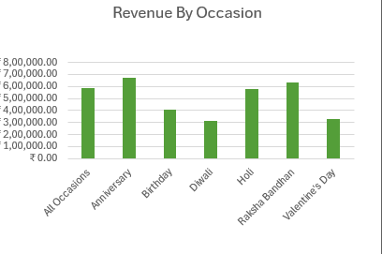

By Category
Colors and Soft Toys are the top-performing categories. Moderate revenue from Cakes and Sweets indicates potential growth opportunities through cross-selling and bundling strategies.
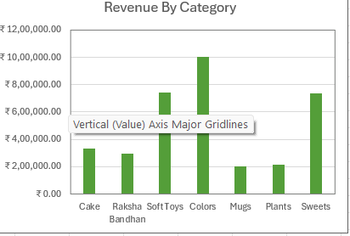

By Hour (Order Time)
Peak revenue hours occur between 6 AM to 10 AM and 8 PM to 10 PM, indicating high customer activity during morning and evening hours. Promotional campaigns and ad placements during these hours can enhance order volumes.
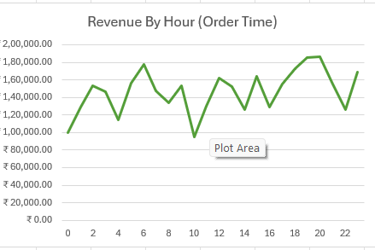

3. Geographical Insights
Cities such as Imphal, Dharbad, Haridwar, and Kavali have shown strong order performance, while Bhagalpur and North Dumdum show moderate order volumes. Targeted regional marketing could help improve sales in lower-performing cities.
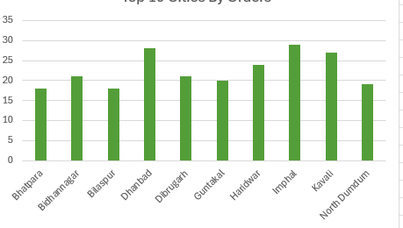

4. Time-Based Trends
February and August have the highest sales peaks, likely influenced by Valentine’s Day and Raksha Bandhan seasons. Noticeable dip in sales during May–June and October–December. Seasonal marketing campaigns and product launches during low-performing months can maintain consistent sales flow.
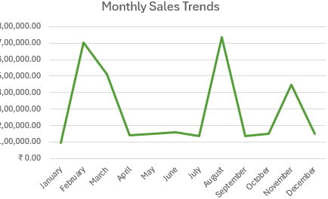

5. Product-Level Insights
Top 5 Products by Revenue:
1. Magnam Set
2. Dolores Gift
3. Quia Gift
4. Harum Pack
5. Deserunt Box
These products represent the best sellers, accounting for a significant portion of total revenue. Continuously promote these items while exploring variations to sustain customer interest.
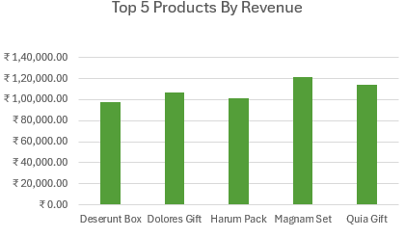

6. Customer Behavior Insights
Average spending (₹3,520) reflects a mid-range customer base. Faster delivery (avg. 5.5 days) enhances customer satisfaction, but further optimization could strengthen brand loyalty. Personalized recommendations and loyalty programs may encourage repeat purchases.

7. Strategic Recommendations
🟢 Focus marketing on high-revenue occasions like Holi, Raksha Bandhan, and Anniversaries.
🟢 Optimize delivery operations to reduce the average delivery duration below 5 days.
🟢 Promote best-selling products in underperforming cities through localized campaigns.
🟢 Introduce combo offers for mid- and low-revenue categories to boost their performance.
🟢 Enhance digital ad scheduling during high-traffic hours (6–10 AM and 8–10 PM).
🟢 Implement seasonal demand forecasting to maintain inventory balance during peak months.
Overall Insights Summary
Key Metric | Observation
Total Revenue | ₹35,20,984
Top Category | Soft Toys (₹7.4L)
Top Occasion | Anniversary (₹6.7L)
Top Month | February (₹7.0L)
Top Day | Sunday (₹6.2L)
Top City | Haridwar
Avg. Delivery Time | 5.53 days

Conclusion
The FNP Sales Analysis Dashboard provides a comprehensive overview of business performance. By leveraging these insights, FNP can strengthen its marketing and logistics strategies, improve customer experience, and drive consistent revenue growth across occasions, cities, and categories.

